**ASSIGNMENT – 2**

1. Create a bulleted list like

* Pradeep
* Pradeep
* Pradeep
* Pradeep
* Pradeep

1. Insert header, footer, and page number.

Ans: 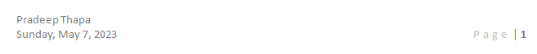



1. Insert a table like this and find out the average of each Mugiwara Pirates using formula.

Ans: 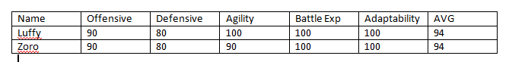

1. Insert a picture in the file, add a thick black border around the picture and insert caption to the picture.

Ans: 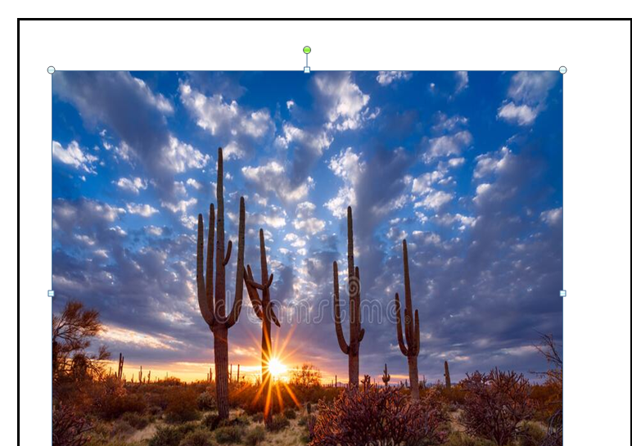

1. Draw any shape using shapes option.

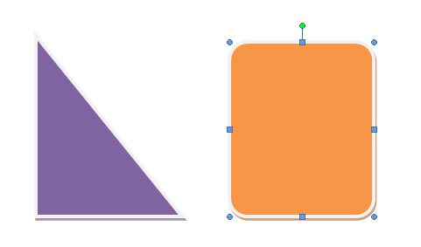

1. Draw any figure using SmartArt option and add some text in the figure.

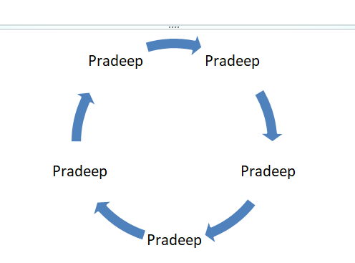

1. Prepare a report on all the Tabs of MS Word [Home, Insert, Design, Layout, References, Mailing, Review, View, and Help]

# Ans: Ribbon and Tabs

The Ribbon is a user interface element which was introduced by Microsoft in Microsoft Office 2007. It is located below the Quick Access Toolbar and the Title Bar. It comprises seven tabs; Home, Insert, Page layout, References, Mailing, Review and View. Each tab has specific groups of related commands. It gives you quick access to the commonly used commands that you need to complete a task.

**See the image:**

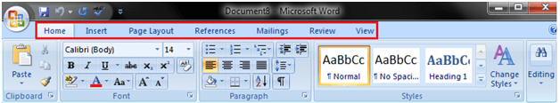

Home tab:

The Home tab is the default tab in Microsoft Word. It has five groups of related commands; Clipboard, Font, Paragraph, Styles and Editing. It helps you change document settings like font size, adding bullets, adjusting styles and many other common features. It also helps you to return to the home section of the document.

**See the image:**

Backward Skip 10sPlay VideoForward Skip 10s

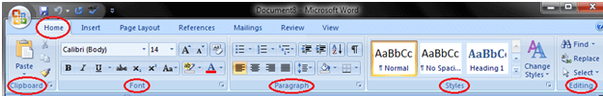

Insert tab:

Insert Tab is the second tab in the Ribbon. As the name suggests, it is used to insert or add extra features in your document. It is commonly used to add tables, pictures, clip art, shapes, page number, etc. The Insert tab has seven groups of related commands; Pages, Tables, Illustrations, Links, Header & Footer, Text and Symbols.

**See the image:**

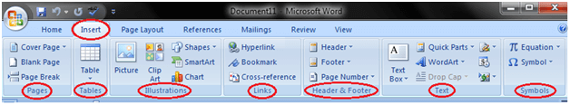

Page Layout tab:

It is the third tab in the Ribbon. This tab allows you to control the look and feel of your document, i.e. you can change the page size, margins, line spacing, indentation, documentation orientation, etc. The Page Layout tab has five groups of related commands; Themes, Page Setup, Page Background, Paragraph and Arrange.

**See the image:**

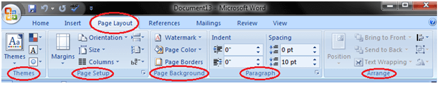

References tab:

It is the fourth tab in the Ribbon. It allows you to enter document sources, citations, bibliography commands, etc. It also offers commands to create a table of contents, an index, table of contents and table of authorities. The References tab has six groups of related commands; Table of Contents, Footnotes, Citations & Bibliography, Captions, Index and Table of Authorities.

**See the image:**

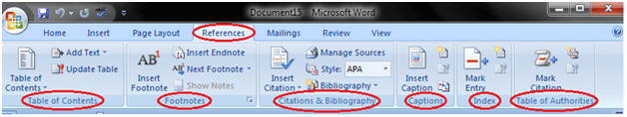

Mailings tab:

It is the fifth tab in the ribbon. It is the least-often used tab of all the tabs available in the Ribbon. It allows you merge emails, writing and inserting different fields, preview results and convert a file into a PDF format. The Mailings tab has five groups of related commands; Create, Start Mail Merge, Write & Insert Fields, Preview Results and Finish.

**See the image:**

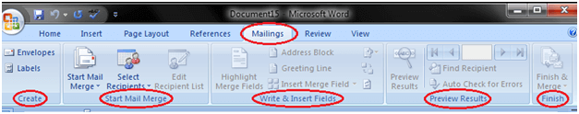

Review tab:

It is the sixth tab in the Ribbon. This tab offers you some important commands to modify your document. It helps you proofread your content, to add or remove comments, track changes, etc. The Review tab has six groups of related commands; Proofing, Comments, Tracking, Changes, Compare and Protect.

**See the image:**

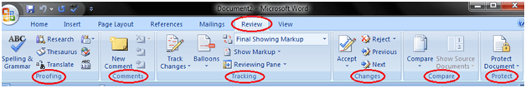

View tab:

The View tab is located next to the Review tab. This tab allows you to switch between Single Page and Two Page views. It also enables you to control various layout tools like boundaries, guides, rulers. Its primary purpose is to offers you different ways to view your document. The View tab has five groups of related commands; Document Views, Show/Hide, Zoom, Window and Macros.

**See the image:**

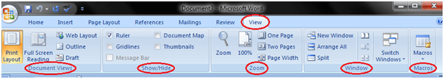

# Ruler

The Ruler is located below the Ribbon around the edge of the document. It is used to change the format of the document, i.e. it helps you align the text, tables, graphics and other elements of your document. It uses inches or centimeters as the measurements unit and gives you an idea about the size of the document.

**See the image:**

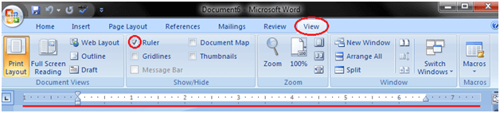

How to Insert Text in MS Word

The basic steps to insert text or to create a new document in Word are listed below;

* Go to the start menu and look for Microsoft Word icon
* Click the icon to open the Microsoft Word
* You will see a blinking cursor or insertion point in the text area below the ribbon
* Now, as you start typing, the words will appear on the screen in the text area
* To change the location of insertion point press spacebar, Enter or Tab keys

**See the image;**

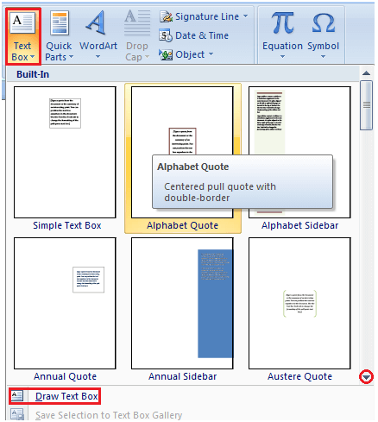

How to Delete Text in MS Word

You can easily delete the text in Word including characters, paragraphs or all of the content of your document. Word offers you different methods to delete the text; some of the commonly used methods are given below;

* Place the cursor next to the text then press Backspace key
* Place the cursor to the left of the text then press Delete key
* Select the text and press the Backspace or Delete key
* Select the text and type over it the new text.

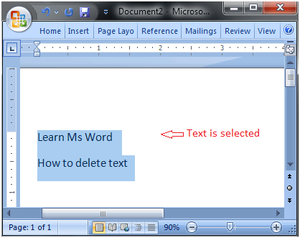

How to Select Text in MS Word

Place the cursor next to the text then left click the mouse and holding it down move it over the text then release it. The text will be selected.

Some shortcuts for selecting text are:

* To select a single word double click within the word
* To select the entire paragraph triple click within the paragraph
* To select entire document, in Home tab, in Editing group click Select then choose Select All option or press CTRL+A
* o Shift + Arrow; hold down the shift key then press the arrow key, the word will select the text in the direction of the arrow key. There are three arrow keys, so you can select the text in three different directions.

**See the image;**

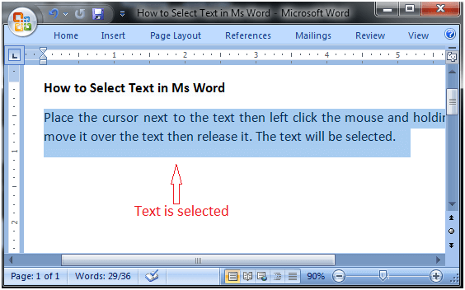

How to Copy and Paste Text in MS Word

Word offers different methods to copy and paste text. Some of the popular methods are given below;

**Method 1;**

* Select the text you want to copy
* Select the Home tab and click the Copy command
* Place the cursor where you want to paste the text
* Click the Paste command in Home tab

**Method 2;**

* Select the text
* Place the cursor over the text and right click the mouse
* A menu will appear; with a left click select the "Copy" option
* Now, move the cursor to a desired location and right click the mouse
* A menu will appear; with a left click select the 'Paste" option.

**See the image;**

Backward Skip 10sPlay VideoForward Skip 10s

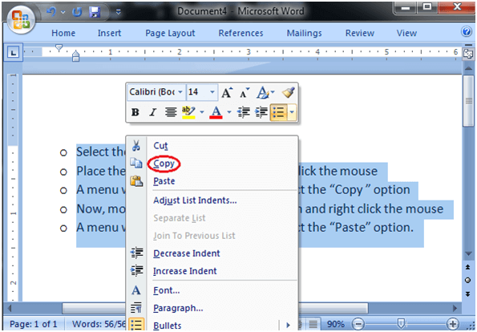

How to Correct Errors in Ms Word

When you type text in a document, by default the Word informs you if there is any contextual, spelling or grammatical error. Word informs you in different ways for different errors;

If there is any contextual error in the document, it will underline the text with blue line.

If there is any spelling error in the document, it will underline the text with red line.

If there is any grammar error in the document, it will underline the text with green line.

Backward Skip 10sPlay VideoForward Skip 10s

**See the image:**

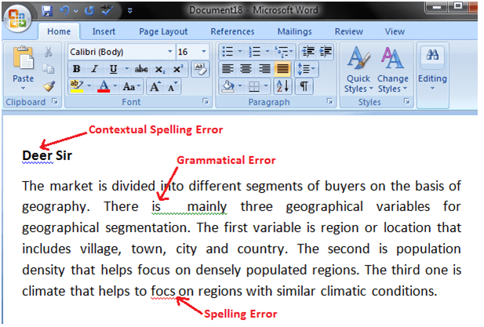

**Steps to correct errors:**

* Place the cursor over the text that you want to correct
* Right click the mouse
* A list of suggestions appears
* Choose the correct word with a left click

**See the image:**

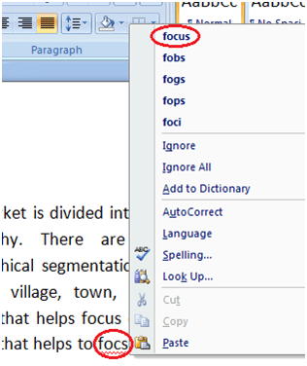

How to Check Word Count in Ms Word

When you start typing, the Word automatically counts the number of words and number of pages and displays the information on the status bar. If the word count is not available on the status bar, you can right click the status bar and select the Word Count option from the menu. Basic steps to check the word count are listed below;

* Open the document
* Look at left bottom corner of the document
* You will see the total world count and the number of pages

**See the image:**

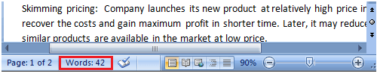

To know the word count of a specific line or paragraph you have to select it then Word will display its word count along with the total word count, e.g. 15/40. In this example, the selection has 15 words out of the total number of words (40).

How to Change Font Size in MS Word

You can easily change the font size of your text in the document. The basic steps to change the Font size are listed below;

* Select the text that you want to modify
* In Home tab locate the Font group
* In Font group click the drop-down arrow next to font size box
* Font size menu appears
* Select the desired font size with a left click
* Select the text and click the increase or decrease font size buttons

**See the image:**

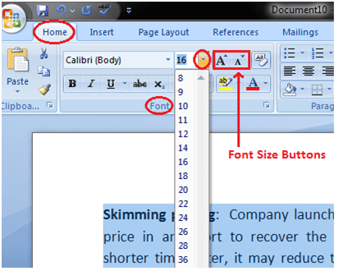

How to Change Font Style in MS Word

The basic steps to change the font of a text in a document are given below;

* Select the text you want to modify
* Select the Home tab and locate the Font group
* Click the drop-down arrow next to font style box
* Font style menu appears
* With a left click select the desired font style
* If you want to change the font to bold or italic, click the 'B' or 'I' icons on the format bar.

**See the image:**

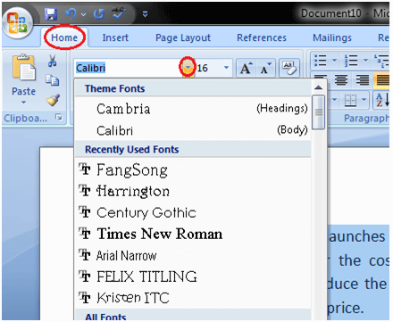

1. Write a newspaper article.

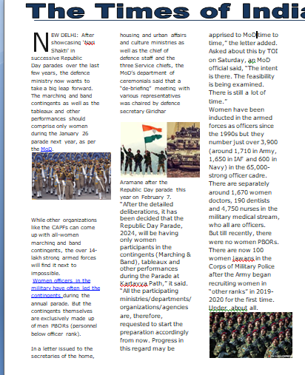

1. Create your CV.

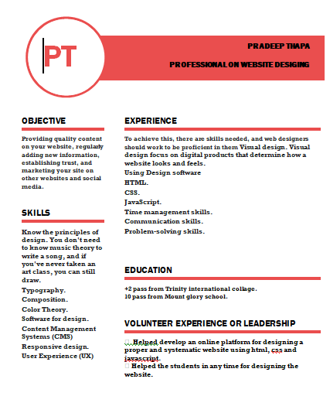

1. Insert Table Of Content and Reference.

